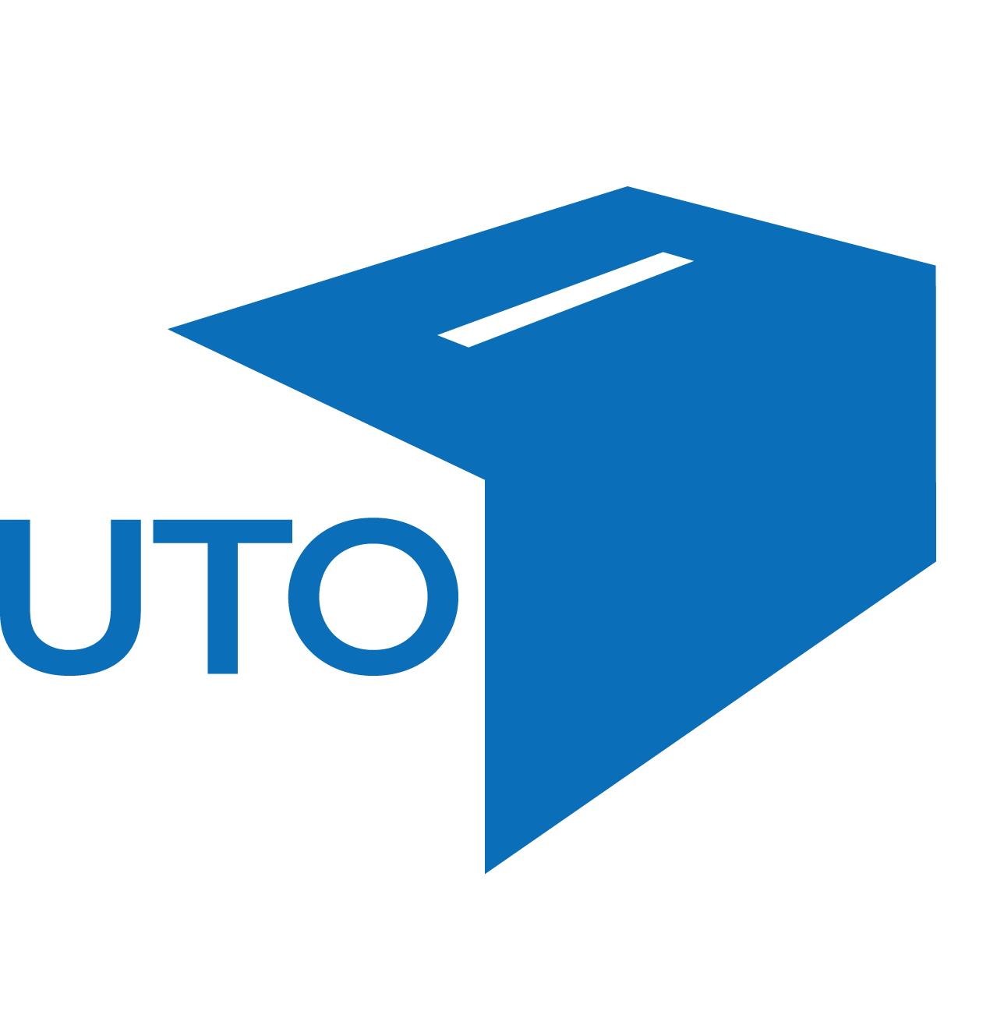
2026 United Thank Offering
Partner Community Application Form

Project Title
Community Partner Name
Name of the Person filling out this form
Contact information for the person named above

- Identify and describe how you were invited or included in developing this project with your Episcopal/Anglican counterpart? (100 word limit)

- How will this project be transformative for your community? (100 word limit)

Community Partner Endorsement
Endorsement is required for all UTO applications in 2026.
Our community is willing to partner with the applicant on this project if awarded. If we are no longer willing to partner on this project, we will notify UTO in writing (hmelton@episcopalchurch.org) as soon as possible.

Name (printed) Signature Date

