
Overview of Materials

November: An Invitation to Grow in Gratitude Together: Introductory Materials
- Welcome Letter from parish leaders to the congregation with an overview of the program and timeline.
- Participation Covenant: A way to invite participation within the context of your congregational system by setting the ground rules on the surveys.
- Sample Sermon on the importance of gratitude to launch the program.
- Formation Activity: Gratitude Chains: Intergenerational faith formation activity.

December: Reflecting with Gratitude on How We Worship
- Introduction of the theme for church leaders.
- Bulletin announcements thanking people for participating so far and introducing the theme.
- Gratitude Survey on worship.
- Formation Activity: Gratitude Game: Pick Up Sticks Sunday School lesson practicing gratitude.
- Take home gratitude activity: Five Things I’m Grateful for…

January: Reflecting with Gratitude on Our Sacred Spaces
- Introduction of the theme for church leaders.
- Bulletin announcements thanking people for participating so far and introducing the theme.
- Gratitude Survey on Sacred Spaces.
- Formation Activity: Thankful, Grateful, Brave youth group lesson helping teens express gratitude.
- Take home gratitude activity: I’m Grateful for My Home.

February: Reflecting with Gratitude on Our Programs
- Introduction of the theme for church leaders.
- Bulletin announcements thanking people for participating so far and introducing the theme.
- Gratitude Survey on programs.
- Formation Activity: Photo Gratitude Scavenger Hunt, an Intergenerational Activity.
- Take home gratitude activity: Photo Gratitude Journal.

Lenten Programming: 40 Days of Gratitude
- Introduction of the theme for church leaders along with UTO Ingathering Information.
- Bulletin announcements thanking people for participating so far and introducing the theme.
- Gratitude Survey on community engagement.
- Formation Activity: Gratitude Time Capsule: an Intergenerational activity
- Take home gratitude activity: UTO Blue Boxes – either journal activity provided or Lenten Materials
- Take home gratitude activity: for families – gratitude countdown to Easter.
https://unitedthankoffering.com/lent/

An Invitation to Grow in Gratitude Together: Introductory Materials

In This Section You Will Find:
- Welcome Letter from parish leaders to the congregation with an overview of the program and timeline.
- Participation Covenant: A way to invite participation within the context of your congregational system by setting the ground rules on the surveys.
- Sample Sermon on the importance of gratitude to launch the program.
- Formation Activity: Gratitude Chains: Intergenerational faith formation activity (can be done at coffee hour) to introduce gratitude as an intentional practice.

An Invitation to Grow in Gratitude Together: Welcome Letter

Note: You are welcome to write whatever introductory letter feels authentic to you, however, we strongly recommend beginning your letter with gratitude and an invitation into the journey of this program. We get that if you have a large congregation this might create a lot of work for you, but we invite you to do it over time and in prayer or break up the list with your staff or vestry. Sit with a list of parishioners/families, a UTO Blue Box, and give thanks for their place in the Body of Christ. Items in red are places where this letter can be customized easily to your context and then placed on letterhead.

You will be enriched in every way for your great generosity, which will produce thanksgiving to God through us; for the rendering of this ministry not only supplies the needs of the saints but also overflows with many thanksgivings to God. II Corinthians 9:11-12

Date

Name
Address

Dear NAME,

Today I am writing to express my gratitude for you and your family, and to invite you to join me on a journey reflecting on the blessings of our life together in Christ in this congregation. I am so grateful for you and all of the ways you contribute to the life of this congregation. Thank you, especially for name specifically one really wonderful thing you’ve noticed this person doing in the life of your congregation and why you are grateful for the gift they shared. Thank you for all of the ways you contribute to building up the Body of Christ in this place and serve as a reminder of Jesus' love in the community as the quote from II Corinthians above reminds us.

Beginning this November and through Easter Sunday, I am inviting our congregation into a time of reflection and gratitude for the gifts and ministries of our common life together. Why gratitude? Gratitude is the Christian response to recognizing that all good things that happen in our lives are gifts from God, a reminder of how much God loves us and wants us to be signs of God’s love in the world. This year, I want to invite you to reflect on the blessings of our common life together, through worship, sacred space, and programs/formation. These reflections are not just another questionnaire, or an opportunity to offer criticism, but a chance to name the ways this congregation is a blessing in your life and give thanks for all of the things you interact with in this place that enhances your experience of your faith and the love of Christ. We are doing this work as a way of introducing one of the oldest ministries of The Episcopal Church, the United Thank Offering (UTO). UTO invites every Episcopalian to adopt a personal spiritual discipline of gratitude and provides materials which will be the basis of our Lenten devotions this year.

If you have any questions about this process at any time during our program, please let me know. Again, thank you for all of the ways you participate in the Body of Christ in this place and for helping our congregation be a sign of Jesus’ love in the community.

Sincerely,

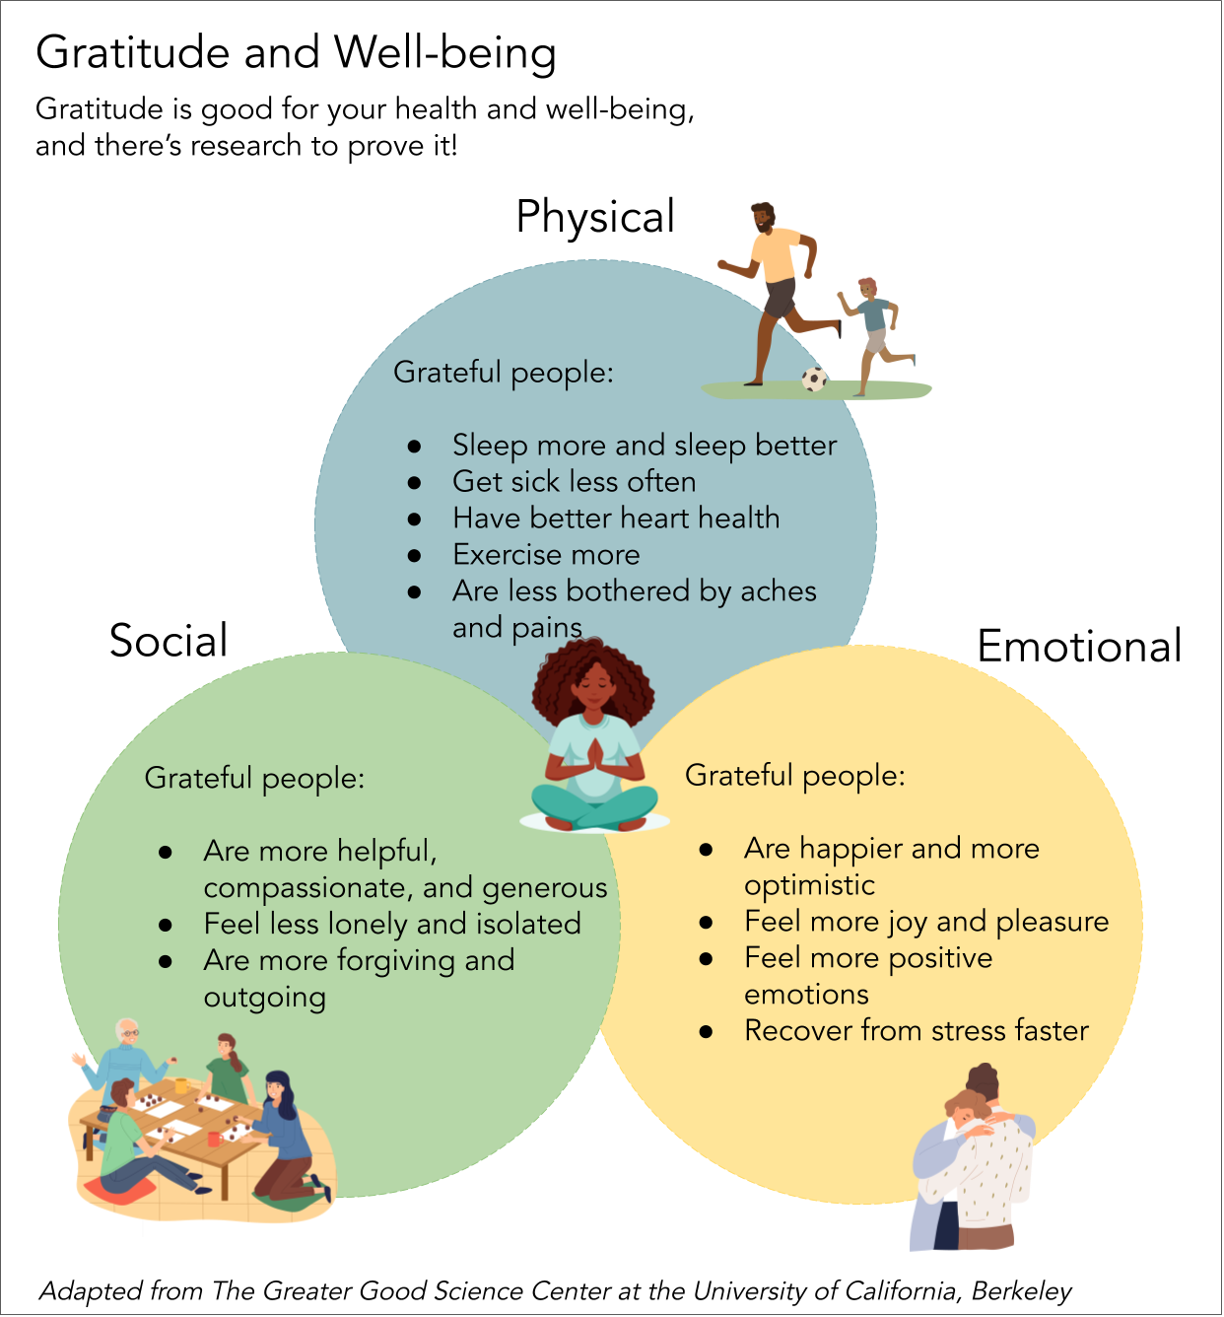

An Invitation to Grow in Gratitude Together: Creating a Participation Covenant

Note: Any time we ask for feedback, it is important to set the ground rules so that everyone participating is set up to succeed. Below are the suggested ground rules, in the form of a covenant, that guided our creation of this program. Please add or edit them as you see fit for your congregation. We know that each congregation is a complex system and a unique creature and therefore we cannot create a covenant that will protect this process and keep it grounded in gratitude without your help of naming and claiming your unique context. You will also need to determine if you want to include this with the introductory letter and collect them or if you want to include it with each survey. Since the survey process is about what we are grateful for, it does not need to be anonymous, but it could be; again, that’s up to you and your context.

An Invitation to Grow in Gratitude Together at CHURCH NAME
Over the next TIME PERIOD CHURCH NAME will be reflecting on all of the good things God is doing in the midst of us to help us create our budget for next year. Our budget will be created out of the gratitude of the members of this congregation as a reminder of where God is calling us to use the blessings of our time, talent, and treasure to build up the body of Christ in this place and to support our gospel imperative to be signs of Christ’s love in the community.

As I join in this journey of gratitude for all of the good things God is doing in the midst of CHURCH NAME, I commit to the following:

- I will pray for our church, church leadership, and community every day.

- I commit to noticing the good things that God is doing in our life together, and in my life outside of church.

- I will honestly and compassionately reflect on the survey each week, knowing that regardless of if I am thankful for the item on the survey, I am thankful for those who share their gift to create that particular item/experience or thankful for those for whom this item is a blessing.

- I will read and pray about each item. I know that the items are not competing for funding and that this is not a vote but that we are simply trying to honor each item and its place in our common life.

- I am committed to commenting only from a place of gratitude and building up by constructive feedback and not indirect or direct criticism offered without help or support.

- I am committed to loving as Jesus loves us, to believe that each person is doing their best and working together to participate fully in the Body of Christ.

Thank you, CHURCH NAME, for the following ways you are blessing me today:

Signed:
An Invitation to Grow in Gratitude Together: Sample Sermon to Begin the Process

Note: Since you can start this program at any time, your opening sermon might be constrained by the appointed lessons. We believe the Gospel should be preached at all times and that the Gospel is a reminder to give thanks for the good things God is doing inside of each of us, in the midst of us and sometimes, in spite of us, therefore it is always a good time to talk about gratitude. What follows is a general outline on gratitude that we hope inspires you to write a beautiful sermon on the lessons in front of you and gratitude.

Have you ever googled “why be grateful”? It’s a really fascinating black hole of information from psychologists, religious leaders of all faiths and even just everyday people who have experienced gratitude changing their life. You’ll find tips to help you practice gratitude, health benefits, and often the case for why grateful people are more generous, happy and fulfilled. As Christians, gratitude is more than just a key to happiness, it’s a spiritual discipline rooted in the belief that everything good that happens around us is generated out of God’s love for us.

Why today’s scripture lesson is a reminder of gratitude and God’s love…

It is easy to forget that we were made by a loving God to be signs of that love in a broken and hurting world. It is easy to get overwhelmed by the brokenness, paralyzed by the wounds the world has inflicted upon us, or simply be caught up in the tasks and busy-ness of our days. And yet, in the midst of all of that God is calling us to gratitude. It is easy to be critical, it is easy to notice what is wrong, broken or annoying, or to simply dismiss or ignore things that don’t bring you joy instead of really critically reflecting on why you keep doing them. I know that I have caught myself in the midst and muck of all of these things only to hear the still small voice of God beckoning me back. It’s easy to get lost. Scarcity and capitalism can sometimes fool us into thinking there isn’t enough to share or that we have earned or deserved the good things that happen in our lives and then we no longer see them as a gift. It’s easy to get there in church life. It’s easy to get busy and to keep doing things without reflecting on why we are doing them or if anyone really needs us to do the things that take up so much of our time and energy. And yet, God reminds us that we were created to be enough, and that we have enough for everyone, and for that I am deeply grateful.

For the next few months, I want to invite you to join me in slowing down, in pausing to reflect and give thanks, to re-center on gratitude for the good things God is doing in this congregation. Each month, we’ll reflect on an aspect of our common life together to determine those things that give us life, those things that might need our attention to do better or things whose time have come to an end and that we should give thanks for the many years they served us well but now will create space, time and energy for God to do something new in their place. We’ll participate in a new activity to help us refocus on gratitude, to deepen our experience of it, and to remind us to respond to the blessings of God with gratitude. Most importantly, we will enter into this as a time of celebration, to give thanks to God and to one another for all of the beautiful and wonderful things we experience from one another…we’ll celebrate all of those things we notice, we’ll celebrate those things that we’re grateful for but take for granted, and we’ll give thanks for the good things that God is calling us to do, beginning with slowing down and noticing the blessings of each day. As we begin, let me start by saying thank you to all of you. Thank you for believing in the mission of this church, for being companions together in faith, and for being a reminder of the love of God to all you encounter in the world each day. I am grateful for you, for this place, and for the ways God’s dream are continuing to be revealed in the midst of us.

An Invitation to Grow in Gratitude Together: Intergenerational Faith Formation Activity

Gratitude Chains

Note:
This gratitude practice comes from a parish UTO Coordinator who wanted to visually show her congregation how much they had to give thanks for in their daily lives. We’ve used it with all ages and for various lengths of time. This project is especially popular at Episcopal Youth Event, where young people came day after day to see how long the chain was getting and what others were thankful for that might inspire their gratitude. You will begin this project in November, and then hang the paper chains for Advent. Feel free to make the paper a color appropriate for Advent or colors that are meaningful to your congregation.

Overview:
Gratitude Chains is a super easy project to help people visualize how many good things God is doing in the midst of their daily life. It’s easy to start at coffee hour, during the announcements or as a part of a parish gathering. It can be done by anyone of any age or ability. You’ll be making paper chains like many of us made as children to decorate our Christmas tree.

Supplies:
Paper cut into slips – these can be as long or short as you want, but long enough that someone can write (or draw) what they are thankful for. We recommend making them in a variety of colors but all the same length.
Tape or staplers to attach the chains
Markers, crayons, pens, etc. for people to decorate or write on their slips

Action:
Invite your congregation to take slips and write one thing on each slip for which they are grateful. You can invite them to take home slips and bring them back the following Sunday, so they can continue to notice and give thanks. We strongly recommend having a stack of slips in each pew that people can fill out while waiting for church to start and put into the offering plate. Once you have a pile of slips begin to assemble them into a chain. Let people know how long this project will last and how long you are hoping to make the chain. For example, we’re going to do this for a month and we want to see how many lengths of the sanctuary we can complete. Then simply remind people, continue to provide paper, and keep adding gratitude links to your chain. When the time has finished, be sure to offer a concluding prayer of gratitude for all of the blessings the chain represents before taking them down.

Segment One
Reflecting with Gratitude on How We Worship

In This Section You Will Find:
- Introduction of the theme for church leaders.
- Bulletin announcement thanking people for participating so far and introducing the theme for the week.
- Gratitude Survey on worship.
- Formation Activity: Gratitude Game: Pick Up Sticks Sunday School lesson practicing gratitude.
- Take home gratitude activity: Five Things I’m Grateful for…

Reflecting with Gratitude on How We Worship:
Introduction for Leaders

This week we’ll begin by focusing on how we worship. For some congregations, this will be super easy and for others this will be a challenge. Episcopalians feel very strongly about worship, regardless of high or low church (however you want to define that), small or big congregations. This is one area of our life together that often falls into the trap of “well, we’ve always done it that way” which can keep us from experiencing the fullness of the Prayer Book or the richness of the diversity of ways to worship within our denomination. It’s also a place where we sometimes forget to look at things with a critical eye. Some aspects of our worship are fraught with good ideas that we’ve picked up when we’ve visited other churches or read an article or participated in workshops on church growth and evangelism. This is a chance to really look at all of these things and figure out what is serving you well, what might not be, and you might even find things that your congregation has completely missed that you did or changed as church leaders. Feel free to customize the survey. We recommend walking in the front door of your church with the survey in hand and writing down everything you see that you hope people engage with when they are gathered on a Sunday morning, from the bulletin boards to the candles on the altar. You might find that something you spend a lot of time on (like that bulletin board) is something people don’t even notice. This means that it frees up the space or your time to do something else. Or you might think no one notices the bulletin board only to find that everyone loves it and finds it helpful, so you’ll feel encouraged to keep it going. You might learn that no one knows the candles are expensive beeswax and would be just as happier with a less expensive version that looks basically the same. The questions driving all of the surveys are: is the time, energy, effort and money behind this item valued or can it be done for less money, or in less time or with less energy so that you can be freed up to do something new, something better, or something with more joy.

This week in the bulletin announcement, we’ve also invited people to bring their favorite photo of the sacred spaces with them the following week for a bulletin board display. Sometimes we forget how a space becomes a part of our lives, from baptisms, weddings, funerals or simply the place where you made a new friend, or experienced Jesus in a new way. All of these pictures are reminders of the centrality of this place in the lives of our fellow congregants and why everyone cares so much about this place.

This week our Faith Formation will focus on helping children reflect on the good things that happen in their life by playing pick-up sticks as a part of a gratitude game. Everyone will be sent home with a gratitude journal page and the invitation to try keeping a gratitude journal using the sheet every day or just as a way to reflect at the end of the week.

Reflecting with Gratitude on How We Worship:
Bulletin Announcements

This Week at Church Name: Reflecting with Gratitude on How We Worship
Thank you for joining us today as we reflect with gratitude on how we worship together. Thank you for filling in our covenant to journey together in gratitude for the next TIME FRAME. If you haven’t received a covenant or the letter that was sent to your home, please let NAME know so we can make sure you receive one. We value your voice and presence in this program and are thankful for your time and participation. Today our children will be learning about gratitude in Sunday School by playing a game of pick-up sticks focused on what they are grateful for in their lives. We hope you’ll take home the instructions and play during the week with the children in your life.

You should have received a survey about what parts of worship you are most grateful for when you come to church. We invite you to be really present during worship today as you consider how we move, pray, celebrate, and function in this space together. What are you most grateful for? Mark those things on the survey. If there are things you simply don’t notice or engage with leave those blank on the survey. Did we ask you about something that you never realized was there but now that you do you’ll engage with it going forward? Let us know! Did we miss something you’re grateful for during worship? Be sure to add it at the bottom. Thank you for taking time to give thanks with us for all of the wonderful things God is doing in the midst of our time together in prayer.

Please bring with you a photo during the next TIME FRAME that expresses your gratitude for our church and an experience you’ve had in this place. Maybe you were married here or made a new friend at coffee hour. Bring a photo for our bulletin board in the LOCATION so we can all give thanks for the way our space blesses you.

Please be sure to pick up this week’s take home gratitude practice: a gratitude journal page. Studies have shown that keeping a gratitude journal is good for your health. This is a quick half-page journal prompt that will help you reflect on the best things you experienced each day, or simply during the week. Be sure to let NAME, our Gratitude Chair, know next week if this helped you seek out the good things happening in your life during the week.

This week during church we’ll be recognizing the contributions of the following groups (in alphabetical order):

Acolytes
Altar Guild
Bulletin Creator/Bulletin Assembly Team
Choir
Clergy
Eucharistic Ministers
Eucharistic Visitors
Flower Guild
Intercessors
Lectors/Readers
Musicians
Ushers/Greeters

Be sure to add any other groups that help lead or support worship at your church.

Thank you to everyone who participates in or leads worship at our church. Many times, your gifts go unnoticed, but it is through your work, your hands, voices, heart and hope that we come together each week to participate in the Eucharist and give thanks with all of the tools necessary.
Reflecting with Gratitude on How We Worship:
Gratitude Survey

Please mark the boxes of the items you are deeply grateful for this morning. Circle items you hadn’t noticed before that now that you see them you are grateful for and will pay attention to going forward.

Please note: leaving an item blank doesn’t mean that you don’t like it or don’t want it, it simply means that the experience of it neither enhances nor impacts your gratitude for being present in worship today.

Today I am grateful for:

- The sign outside of church
- The entryway/a safe place for my coat
- Children in worship materials
- Bulletin
- Bulletin board
- Brochures with information about our church
- Invitations to church functions
- Nametags
- Signs for the bathroom
- Announcements in the bulletin
- Prayer Book
- Hymnals
- Candles
- Communion Wafers
- Music
- Organ/Piano/Music Team
- Styles of the Prayers of the people
- Communion wafers/bread
- Seasonal art/decorations
- Flowers
- Prayer A
- Rite II

- PLEASE ADD AS MANY ITEMS AS YOU CAN THINK OF…

I’m also grateful for these things which were not on the list but that I experience while in worship at church name:

Reflecting with Gratitude on How We Worship:
Faith Formation Focus for Children

Gratitude Game: Pick Up Sticks*

Note:
While this activity is intended for children to do in Sunday School, it can easily be done as an intergenerational activity either at Coffee Hour or as a part of a parish forum. It would be a fun activity to mix up age groups and have them hear from one another the things they are most grateful for in the categories listed or ones you come up with specific to your context. (Note: there are jumbo pick up sticks available online that are fun to use with a big group.)

Supplies Needed:
- Pick Up Sticks, the game
- Gratitude Game Board (see next page)

Background: Children are naturally very good at gratitude, maybe because they depend on others so much for so many things, or maybe because they haven’t yet forgotten the impact of when they say ‘thank you’. Teaching children gratitude is important because they will often remind others, through their example of giving thanks, to join them in practicing gratitude. Today we’ll help the students see all of the things in their life that they can give thanks for and encourage them to keep giving thanks to God for all of the good things happening in their life.

Lesson:
Read the scripture verse that you’ve chosen for the lesson. We recommend using: Psalm 105:1-6, 37-45
Discuss with the students what the lesson means. If using the recommended lessons some questions might be:
- What was the best thing that happened to you this week?
- What was the best trip you ever went on?
- What was the most fun thing you did at school this week?
- What is your favorite place to visit?
- What thing would you like to be able to do?

Gratitude Game:
Using the game Pick Up Sticks, and the rules that come with it, (you can find the rules here: https://www.fgbradleys.com/rules/Pick%20Up%20Sticks.pdf) play a round of Pick Up Sticks, however, depending on what color the student picks, they need to share something they are grateful for using the Gratitude Game Board. (Feel free to adapt the categories to what best meets the needs in your community. You can also build your own sticks for the Gratitude Game using instructions found here: http://teachbesideme.com/gratitude-game-pick-sticks/)

After the game: ask the students, was one color harder than the others to think of things that you’re grateful for? Was one color the easiest to think of things from? What other categories could we have used? What are you most thankful for today?

Invite them to challenge their families to find at least one thing each day to be grateful for each day and keep the slips of paper in a basket/UTO Blue Box to reflect on at the end of the month.

*A big thank you to http://teacgbesideme.com/gratitude-game-pick-sticks/ for the idea behind this project.

Reflecting with Gratitude on How We Worship:
Take Home Gratitude Activity

Five Things I’m Grateful For…A Fast Journal Page
Note: Keeping a gratitude journal does not need to be labor intensive, it can be as simple as writing down five good things that happened today. We’ve created a form (below) for you to send home for your congregation to use to track the five best things that happened to them this week and how they feel about the week overall. This is also a great way to help young people start their own gratitude practice.

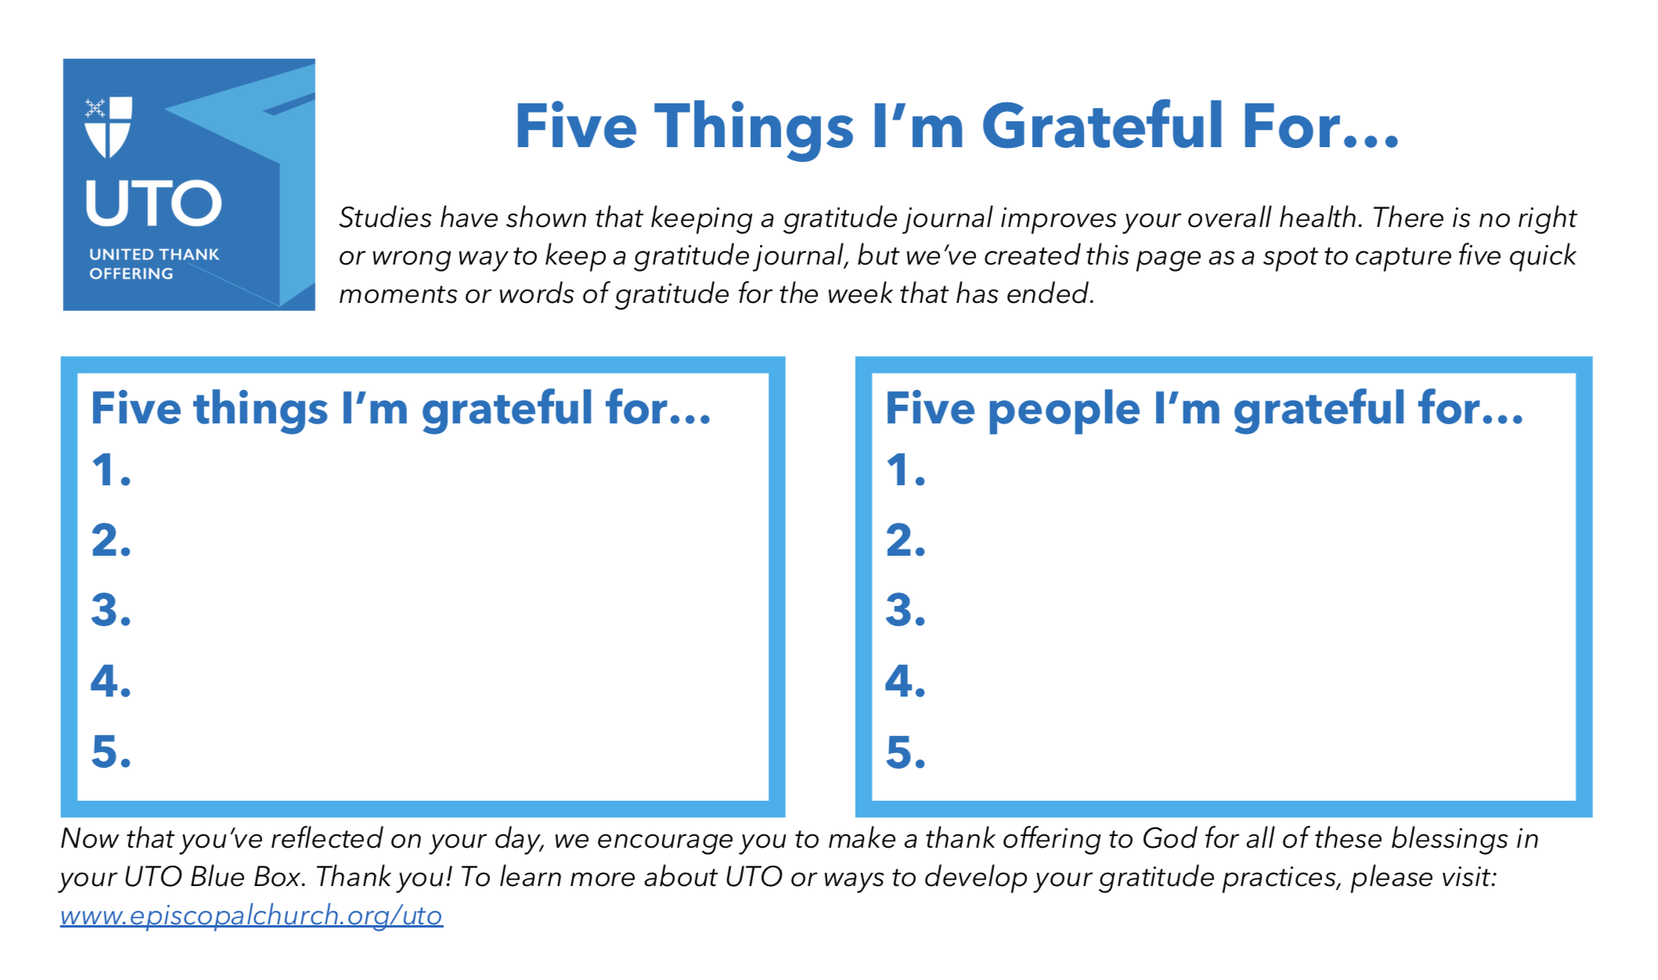


Segment Two
Reflecting with Gratitude on Our Sacred Spaces

In This Section You Will Find:
- Introduction of the theme for church leaders.
- Bulletin announcements thanking people for participating so far and introducing the theme.
- Gratitude Survey on Sacred Spaces.
- Formation Activity: Thankful, Grateful, Brave youth group lesson helping teens express gratitude.
- Take home gratitude activity: I’m Grateful for My Home.

Reflecting with Gratitude on Our Sacred Spaces:
Introduction for Leaders

Welcome to week two! Last week we focused on worship, which is probably the easiest of the sections for people to reflect on together. This week we move on to our Sacred Spaces, or buildings and grounds. As a parish priest, I often found that taking care of our sacred spaces consumed more time than I would have guessed and more work than seminary prepared me to deal with. When we enter into a public space we expect it to be clean, climate controlled, and cared for and we often only notice when they’re not. What I came to learn is that a lot of time, energy and funding goes into keeping our buildings and grounds not only functional, but welcoming and lovely. Helping our congregation give thanks for the aspects of our sacred spaces that often go unnoticed is important because it is a reminder that we all need to be good stewards of our spaces and how much work and expense the physical plant actually is within our budget. Some congregations have wonderful practices around the care of their buildings, some as simple as, if you use something up, bring a replacement. Other congregations find that the care of the buildings and grounds falls solely on staff. Either way, it’s a lot of work and a lot to give thanks for. We also want to reflect on how our Sacred Spaces are the foundation for all kids of wonderful things we can do and that the spaces shape the ministries housed within.

Some of the items on the survey might feel silly, but it is important to recognize that everything within this category is often the result of someone thinking of others. Almost everyone I know is probably grateful for the bathroom to be stocked with supplies, but has anyone ever thanked the person who makes sure it is stocked? If your congregation utilizes staff to ensure the sacred spaces are stocked and cared for it is easy to ignore the importance of being grateful for the time the person put into it. Even if it is your job, it is nice to be appreciated for doing it well, or with care and compassion. As human beings, we long to be recognized and thanked for our contribution to the good of the order, even if it is for doing the most mundane of tasks that make the lives of others easier or better.

This week the bulletin announcement will also thank people for participating last month. We’ll invite you to share the most surprising thing you learned and the thing you were most grateful to see. We’ll remind them of the covenant and the goals of this work. Once again, we’ve put a place in the sample bulletin announcement to thank people, but we also recommend doing it during worship. There is always the fear that when we thank someone publicly we’ll forget someone, so be sure to ask someone to check your list before recognizing people so as to not leave anyone out.

Reflecting with Gratitude on Our Sacred Spaces:
Bulletin Announcements

This Week at Church Name: Reflecting with Gratitude on Our Sacred Spaces
Thank you for joining us for worship today as we reflect with gratitude on the sacred spaces of CHURCH NAME. Thank you for filling in our covenant to journey together in gratitude through Easter. If you haven’t received a covenant or the letter that was sent to your home, please let NAME know so we can make sure you receive one. We value your voice and presence in this program and are thankful for your time and participation.

Last month, we reflected with gratitude on how we worship together; thank you for filling out and returning the survey! As we reflected on your answers, we were so thankful for your time and for all of the ways our worship gives you joy and sustenance for the week ahead. We were surprised to learn that people were especially grateful for NAME SOMETHING SURPRISING. We learned that NAME SOMETHING MOST PEOPLE AGREED UPON. If you didn’t get a chance to turn in your survey or fill one out, you are most welcome to still do so. Please see NAME, to get the materials from last month and turn them in by END DATE. Regardless, please let people know you are grateful for them, their ministry or role in our community life, as there’s never a moment that’s not appropriate to give thanks. Thank you to everyone who brought photos this week. Be sure to hang them up in LOCATION.

You should have received a survey about what aspects of our sacred spaces you are most grateful for when you come to church. We invite you to be really present today as you consider how we move and function in this space together. What are you most grateful for? Mark those things on the survey. If there are things you simply don’t notice or engage with leave those blank. If we asked you about something that you never realized was there but now that you do you’ll engage with it going forward, let us know! Did we miss something you’re grateful for during your time here? Be sure to add it at the bottom. Thank you for taking the time to give thanks with us for all of the wonderful things God is doing in the midst of our sacred space.

Today our teens will be thinking about all of the people for whom they are grateful and the things they are grateful for that they contribute to the community. They will send thank you cards to someone in youth group, someone in the community that they admire, and one to themselves. If you would like to send a thank you card to our young people this week, please do! You can send them directly using the church directory or drop them off in the office to be forwarded.

Please be sure to pick up this week’s take home gratitude practice: “I’m grateful for my home,” an opportunity to reflect on the blessings of the places that provide us shelter and the things we place in them that make it home. Be sure to let NAME know next week if this helped you seek out the good things happening in your life during the week.

This week during church we’ll be recognizing the contributions of the following (in alphabetical order):
Building Committee
Cleaning Crew
Custodian/Sexton
Landscaping Crew
Volunteers who stock bathroom supplies
Volunteers who stock kitchen supplies
Be sure to add any other groups that help lead or support the care of sacred spaces.

Thank you to everyone who helps care for our Sacred Spaces. Many times, your gifts go unnoticed, but it is through your work, your hands, your sweat and intentionality that we come together each week in a safe, comfortable space to participate in the Eucharist and give thanks.
Reflecting with Gratitude on Our Sacred Spaces:
Gratitude Survey

Please mark the boxes of the items you are deeply grateful for this morning. Circle items you hadn’t noticed before that now that you see them you are grateful for and will pay attention to going forward.

Please note: leaving an item blank doesn’t mean that you don’t like it or don’t want it, it simply means that the experience of it neither enhances nor impacts your experience in our sacred spaces.

Today I am grateful for:

- Gardens outside of church
- Parking lot
- Handicapped accessibility
- Welcoming front door/entry
- Electricity
- Climate control
- Clean sanctuary
- Comfortable seat and space to worship in
- Stained glass windows
- Sanctuary light
- Well cared for floors, walls, etc.
- Bathrooms, clean and accessible
- Faith formation spaces
  - Cheerful places to learn
  - Clean and organized
- Storage spaces clean and organized
- Kitchen
  - Dishes and pots/pans
  - Silverware, knives, tools
  - Clean and organized
- Technology
  - Wifi
  - Televisions, etc. for watching presentations
- Play area for children well-tended
- Playground safe and well-tended

- PLEASE ADD AS MANY ITEMS AS YOU CAN THINK OF…

I’m also grateful for these things which were not on the list but that I experience while onsite at church name:

Reflecting with Gratitude on Our Sacred Spaces:
Faith Formation Focus for Teens

Thankful, Grateful, Brave
Background: Many teenagers (and even some adults) often forget to say thank you to the people we engage with on a regular basis. Saying thank you also requires a level of vulnerability and bravery. When we acknowledge our gratitude simply for the presence of another, we also acknowledge our connections, dependency, and that the person we are most grateful for is often the person we feel safest with to be our true self, or not always be our kindest self. Today we want to take a moment with our young people to help them say thank you to people simply for being in their life. Teenagers are in the midst of self-differentiation and finding their voice in the midst of what can be crushing peer pressure and the demands of growing up in a digital age. Helping our young people identify those individuals who can encourage and support them within the church and in the community is important support, and teaching them to express gratitude an important skill; both take bravery to do because they require an element of vulnerability (naming that you need help and letting someone know you need them) but these are important life skills that will serve them well for years to come. Additionally, it’s something all of us need a reminder of, that God created us for one another and that we should give thanks for the blessings of our relationships. We will also give them a chance to send a thank you note to their future self, because gratitude is one expression of being gentle with ourselves.

Supplies Needed: Thank You cards-at least three for each student and stamps.

Lesson: Read the scripture verse that you’ve chosen for the lesson we recommend using: Psalm 105:1-6, 37-45. Discuss with the students what the lesson means. If using the recommended lessons some questions might be:
- What was the best thing that happened to you this week?
- What was the best trip you ever went on?
- Where did you see kindness at school this week?
- What is the nicest things someone has ever done for you?

Project: Pass out a thank you card to each student. Invite them to write a thank you note to someone at church. You can also do this verbally by inviting each student to share something they are thankful for about someone else in the room. It’s up to you and the maturity of the group. Pass out a second card. Ask them to write a thank you card to someone not in the room. It can be a family member, someone in the community or even a celebrity, someone they look up to that they are grateful for how that person lives their life and is an example to them. Pass out the third card and invite the students to write a thank you note to themselves. Imagine yourself ten or fifteen years in the future. What will you be doing? What things are you thankful you tried, learned or encountered? What would you in the future thank you for doing now that would help you achieve your dreams? If you could do or be anything, what skills will you need to get there, whose help will you need? Who will you need to thank and what will you need to thank yourself for? While they are writing, let them know that you have also written a thank you note to each of them (or will write while they are writing). Tuck this note into the same envelope as the card they write to themselves.

Closing: Collect the letters that the students have written after they have sealed them. Let them know that you will mail the cards for them this week but that you will hold the cards they wrote to themselves and mail them at a later date but prior to graduation so they can be reminded on a day when they might need it most, that they are a blessing from God to the community.
Reflecting with Gratitude on Our Sacred Spaces:
Take Home Gratitude Activity

I’m Grateful for My Home
Shelter is one of the three basic human needs. Many of us are grateful for the place where we live while some of us live in a place or situation that feels unstable or that perhaps we might be thinking about moving. Regardless, within the walls of the place we call home or where we live are often things that bring us joy, remind us of happy times, celebrate the journey our life has taken or simply serve us well. We invite you to take time to celebrate your home and the things inside of it that bring you joy, comfort or hope.

Five photos I’m grateful for…
1.
2.
3.
4.
5.
Five objects I’m grateful for…
1.
2.
3.
4.
5.

Five moments my home reminds me of today that I’m grateful for…
1.
2.
3.
4.
5.
Five tools I’m grateful for…
1.
2.
3.
4.
5.

Five items that make my home cozy that I’m grateful for…
1.
2.
3.
4.
5.
Five things that remind me of a vacation/trip that I’m grateful for…
1.
2.
3.
4.
5.

Now that you’ve reflected on your home, we encourage you to make a thank offering to God for all of these blessings in your UTO Blue Box. Thank you! To learn more about UTO or ways to develop your gratitude practices, please visit: www.episcopalchurch.org/uto
Segment Three
Reflecting with Gratitude on Our Programs

In This Section You Will Find:
- Introduction of the theme for church leaders.
- Bulletin announcements thanking people for participating so far and introducing the theme.
- Gratitude Survey on programs.
- Formation Activity: Photo Gratitude Scavenger Hunt, an Intergenerational Activity.
- Take home gratitude activity: Photo Gratitude Journal.

Reflecting with Gratitude on Our Programs:
Introduction for Leaders

Welcome to month three! Last month we focused on sacred spaces, which likely brought to light for members of your congregation the many things behind the scenes that keep your church open, safe and functioning. We hope that it has helped you think critically about your space (maybe you’ve got a work day scheduled to follow up on a project area) because your space is really key to this week’s focus—programs. This month might hit close to home for many priests, deacons, and church leaders who have tried and failed (or tried and succeeded) to start new programs at church. We’ve all heard the same studies and information that show that families are feeling overscheduled and overprogrammed and yet we also believe deeply as a church in the importance of faith formation or religious education. Many of us have deep gratitude for a program or event at church that really taught us something about our faith or ourselves. If we’re being honest, many of us have also spent hours putting together a program that we think will just be amazing only to have no one show up or only one or two people when you were ready for twenty. Perhaps you’ve had the opposite…maybe you forgot to prepare for your lectionary study only to find twenty people waiting to join you. Programs are often unpredictable. What works one year, might not work the next, or something that flopped might have simply failed because of the timing, not the content. There are a lot of options when it comes to programs and you probably know what is working and what isn’t, but the goal of this week is to really hear and experience the gratitude of your congregation for these programs, regardless of if they could come or not. The survey might open up bigger conversations and discernment about what kinds of programs people are interested in. Even this stewardship program is designed to help your congregation experience some types of formation that they might not have before, like take home work and intergenerational activities.

This week’s survey is a little different. We’re going to ask what programs people are grateful for and which ones they have participated in or would participate in if the schedule allowed. This is really important. I can be grateful that my priest leads a Bible Study each week and still not want to attend it, but it’s more important to discover that I am grateful that the Daughters of the King are a part of our congregation, I just wish they met on a week night instead of Sunday afternoon. This helps leaders think critically about the programming they offer and how they might expand, contract, or try something new.

Again, the bulletin announcement will also thank people for participating last month. We’ll invite you to share the most surprising thing you learned and the thing you were most grateful to see. We’ll remind them of the covenant and the goals of this work. Once again, we’ve put a place in the sample bulletin announcement to thank people, but we also recommend doing it during worship. There is always the fear that when we thank someone publicly we’ll forget someone, so be sure to ask someone to check your list before recognizing people so as to not leave anyone out.

Reflecting with Gratitude on Our Programs:
Bulletin Announcement

This Week at Church Name: Reflecting with Gratitude on Our Programs
Thank you for joining us for worship today and reflecting with gratitude on the programs at CHURCH NAME. Thank you for filling in our covenant to journey together in gratitude through Easter. If you haven’t received a covenant or the letter that was sent to your home, please let NAME know so we can make sure you receive one. We value your voice and presence in this program and are thankful for your time and participation.

Last month, we reflected with gratitude on our sacred spaces, and you were encouraged to bring photos of moments that took place here that you were grateful for; thank you for filling out and returning the survey and bringing photos! We’ve hung your photos in PLACE and some are included in this bulletin insert. As we reflected on your answers, we were so thankful for this place and the way it provides a respite for us on our life journeys. We were surprised to learn that people were especially grateful for NAME SOMETHING SURPRISING. We learned that NAME SOMETHING MOST PEOPLE AGREED UPON. If you didn’t get a chance to turn in your survey or fill one out, you are still welcome to do so. Please see NAME to get the materials from last month and turn them in by END DATE.

You should have received a survey about our programs. This week our survey is a little bit different. We invite you to be really present today as you consider the educational and formational activities that we offer. What are you most grateful for that you’ve participated in? Mark those things on the survey. If there are things you simply don’t notice or engage with leave those blank. Did we ask you about something that you never realized was there but now that you do you’ll engage with it going forward? Let us know! Mark those items you would attend gratefully if they were only offered at a different time. Did we miss something you’re grateful for during your time here? Be sure to add it at the bottom. Thank you for taking the time to give thanks with us for all of the wonderful things God is doing in the midst of our time together.

Today we’ll be hosting an intergenerational event during our usual parish forum/coffee hour time. Bring your phone, digital camera or other way to share digital images with a small group. We’ll break into groups and share photos that remind us of things we are grateful for and share why. This is a fun activity that’s easy to do at home and especially great to do at the holidays with your family. Please join us!

Please be sure to pick up this week’s take home gratitude practice: photo challenge! To build upon our adult forum/coffee hour, we’re sending you home with a sheet to help you proactively look for opportunities to give thanks. Fill it out, encourage a friend to do the same and then share your sheets and stories at the end of the week. Be sure to let NAME, Gratitude Chair, know next week if this helped you this week.

This week during church we’ll be recognizing the contributions of the following (in alphabetical order):

Bible Study Leaders
Daughters of the King
Easter Egg Hunt Leaders and Volunteers
Education for Ministry Leaders
Nursery Volunteers
Parent Assistants
Sunday School Teachers
Youth Group Leaders

Be sure to add any other groups that help lead or support the care of sacred spaces.

Thank you to everyone who supports, attends or leads programs at our church. Your gifts help us to strengthen and deepen our commitment to Christ and to one another as we grow in faith and fellowship. Thank you!
Reflecting with Gratitude on Our Programs:
Gratitude Survey

Our survey for this section looks a little different. We invite you to consider all of the programs that are offered at church name. Please mark those programs in which you have or are currently participating and leading. Or mark those which you would attend if they were offered at another time.

Today I am grateful for:
Program | I Am Grateful to Attend and/or Contribute | I would gladly and gratefully attend if it were at a different time.
Sunday School
Youth Group
Bible Study
Intergenerational Activities
Advent Activity Hour
Easter Egg Hunt
Daughters of the King
Education for Ministry
Godly Play

I’m also grateful for these things that were not on the list but that I experience as program or formation at church name:

Finally, as I reflect, I realize that I am grateful to work with parish leaders on transitioning out of leadership of the following ministries and training my replacement so that I might participate in new ministries at church name.

Reflecting with Gratitude on Our Programs:
Intergenerational Faith Formation Activity

Photo Gratitude Scavenger Hunt
Background: Many of us now take a lot of pictures with our phones, then forget to ever print or share them with others. Often a snapshot is something we are grateful for-a sunset, a person, an experience or a moment in time that we don’t want to forget. So today, at coffee hour/parish forum we’re going to break into mixed-aged groups and do a phone photo scavenger hunt—each of you will get a chance to share the photos on your phones that show moments of gratitude with those you love and learn about others in the congregation and the things for which they are grateful.

Supplies Needed: The list below, a timer and photos on your phone/digital camera or other device.

Project: For this hunt, one person will read the category to the group and set a timer. Everyone will have two minutes to search through their photos on their phones to look for the one that best describes the category. (Invite children without phones to help someone with theirs or draw a quick picture.) No new pictures are allowed, only ones currently on the phone. When the time is up, each person shares the photo they chose and why. If they don’t have a photo to share, invite them to simply share why they are grateful for that category.

I’m Grateful for...
- My family
- My friends
- An adventure
- A vacation or trip
- A quiet place
- A beautiful spot
- A favorite art project/piece of art
- A funny video
- Someone who can’t be with us today
- My health and happiness

Closing: Invite each group to share with each other what story or photo they were most grateful to receive from the group. Then invite people to share, as they feel called, what they learned about each other and the blessings they got to learn about in the photos with the full group.

*Adapted from www.kcedventures.com

Reflecting with Gratitude on Our Programs:
Take Home Gratitude Activity

Photo Gratitude Journal
This week we looked back at our photos to reflect and share stories of times when we were grateful. This week we’ll practice being proactive about taking photos of things that cause us to pause and give thanks, recognizing that all things are gifts from God. Snap a picture and put it in the squares. Challenge someone to do the same and then join you to share the stories behind the photos at the end of the week over a cup of coffee or tea.

I’m grateful for how I felt when I was taking this picture:

I’m grateful for how I felt in this picture:

I’m Grateful for this place:

I’m grateful for this person:

I’m grateful for this moment:
I’m grateful for nature:

Section Four:
Reflecting with Gratitude on Our Community Engagement

In This Section You Will Find:
- Introduction of the theme for church leaders.
- Bulletin announcements thanking people for participating so far and introducing the theme.
- Gratitude Survey on Outreach Ministries.
- Formation Activity: Gratitude Time Capsule
- Take home gratitude activity: UTO Lenten Materials

UTO Ingathering Information Links:
This month you will introduce the United Thank Offering and its connection to collecting thank offerings which are then awarded as grants to support innovative mission and ministry within The Episcopal Church and Anglican Communion. What follows are some links which will help you prepare for an ingathering and will enhance the materials presented here. We are connecting how your congregation engages with the community with the Ingathering to help you engage with the congregation around broader theological themes (ex. Responding to the gifts that God has given us by helping others, either in person or via UTO).

Helpful UTO Links:
- Order UTO Materials Here: https://shimaofnavajoland.com/collections/united-thank-offering
- Everything you might need to run an Ingathering, from sample bulletin announcements, liturgical items, “I gave online” cards, QR codes, and more are available here: https://unitedthankoffering.com/ingathering/

Reflecting with Gratitude on Our Community Engagement:
Introduction for Leaders

Welcome to the final month of this program! Today we begin our final section of reflection and gratitude by turning our focus outward to how your congregation engages with the community in which you are apart. Every congregation engages with their community differently, which makes building this section particularly difficult. With that said, there are two major ways we engage with our communities: service/advocacy/justice or evangelism/invitation/connection. We’ll try to focus equally on both aspects, knowing that many congregations might do one better than the other or might be struggling to do either. We also know that in this post-pandemic era, many congregations have stopped doing outreach or changed how it is done, so we hope that this section will help you evaluate and plan a way forward. We do combine this section with UTO materials, because UTO is one of the ways that we can do outreach. Oftentimes when someone tells me they feel overwhelmed by some of the big issues plaguing our world today, I remind them that UTO connects us through our thank offerings with people who have an idea to try and make a difference. Funding mission and ministry and connecting to it around the globe is a great way to start outreach.

This month, the survey has two columns, one for each way congregations can engage with their community. You might think of a third way; be sure to include that as well, as we’ve only made the broad categories as way to delineate between two very different forms of engagement and yet show that both are key to the Jesus Movement. As you know, we’ll once again use the bulletin insert to introduce the theme and thank leaders in the areas addressed. We will use the formation time to engage the congregation with a gratitude time capsule. You will need something to collect notes of gratitude in (you can use a giant UTO Blue Box or just a cardboard box wrapped in blue paper) that connects the action with UTO. This will help you begin to not only remind your congregation of the importance of gratitude as a spiritual discipline but will be a wonderful thing to open up in November when you begin your stewardship program (you can even utilize our gratitude-based pledge cards found at www.unitedthankoffering.org/stewardship )

For Faith Formation this month, we invite you to connect with UTO Lenten programs and offerings. Each Lent, UTO offers a book club on zoom, daily gratitude prompts on social media (that you can share on your congregations page), a text message prompt, and materials for families. Instead of including those here, you can find the newest materials at: www.unitedthankoffering.org/lent. If you have started this program in such a way that you are not ending during Lent, we’ve included a take home activity that allows people to turn their Blue Box into a gratitude journal (similar to the time capsule) that they can use to hold notes of gratitude and then make a thank offering on UTO Sunday.

Reflecting with Gratitude on Our Community Engagement:
Bulletin Announcement

This Week at Church Name: Reflecting with Gratitude on Our Community Engagement

Thank you for joining us for worship today and reflecting with gratitude on the ways CHURCH NAME engages with our community. Thank you for filling in our covenant to journey together in gratitude for the next TIME FRAME.

Today begins our last section of reflection together. If you haven’t received a covenant or the letter that was sent to your home, please let NAME, Stewardship Chair, know so we can make sure you receive one. We value your voice and presence in this program and are thankful for your time and participation. Last time frame we reflected with gratitude on our programs. Thank you for filling out and returning the survey! As we reflected on your answers, we were so thankful for this place and your willingness to grow in faith together inspite of your busy schedules. We were surprised to learn that people were especially grateful for NAME SOMETHING SURPRISING. We learned that NAME SOMETHING MOST PEOPLE AGREED UPON. If you didn’t get a chance to turn in your survey or fill one out, you are still welcome to do so. Please see NAME to get the materials from last TIME FRAME and turn them in by END DATE.

You should have received a survey about our community engagement. There are two columns this week: how we serve and how we invite. We invite you to be present today as you reflect on the ways we engage and invite members of our community to join us on the journey here at Church Name. Think about what first drew you to come visit. Why did you stay? Did someone invite you? Share these things with us on the survey so we can give thanks for the ways you were drawn into our church community. Mark those things on the survey that our congregation does to serve and connect with our community for which you are grateful. If there are things you simply don’t notice or engage with leave those blank. Did we ask you about something that you never realized was there but now that you do you’ll engage with it going forward? Let us know! Did we miss something you’re grateful for during your time here? Be sure to add it at the bottom. Thank you for taking the time to give thanks with us for all the wonderful things God is doing in the midst of our time together.

Today we’ll be hosting one last intergenerational event during our usual parish forum/coffee hour time. We’re going to start a gratitude time capsule that we’ll use throughout the season of Lent. Please join us! Please be sure to pick up this week’s take home gratitude practice: UTO Lenten materials. We have materials for all ages, including a countdown to Easter for families, a way to sign up to get text message prompts to practice gratitude each day, and lots of UTO Blue Boxes to choose from. We will hold our UTO Sunday on date.

This week during church we’ll be recognizing the contributions of the following (in alphabetical order):
After School Program Volunteers
Community Garden Leaders and Volunteers
Evangelism Team
Holiday Planning and Invitation Team
Soup Kitchen Leaders and Servers
Be sure to add any other groups that help lead or support your community engagement ministries.
Thank you to everyone who volunteers their time to help those in need in our community and to everyone who invites friends and family to join you here for worship. Your time and talent are a reminder that Jesus called us to seek him out in the least, the lost, and the lowly and to care for him there. Thank you also for each time you tell the good news of what God is doing in this place as a way to invite others to journey with us. Thank you!
Reflecting with Gratitude on Our Community Engagement:
Gratitude Survey

This morning our survey is a little different:
- Please mark the boxes of the items you are deeply grateful for this morning.
- Circle items you hadn’t noticed before, but now that you see them you are grateful for others doing and might join in next time.
Please note: leaving an item blank doesn’t mean that you don’t like it or don’t want it, it simply means that the experience of it neither enhances nor impacts your gratitude for how our congregation engages with our community.

Today I am grateful for:

Service/Justice/Advocacy Work:
- After School tutoring program
- Free Summer Camp
- Hosting AA groups
- Youth summer mission trips
- Job skills training programs
- Warming shelter in the winter
- Domestic Violence awareness and
prevention training
- CPR Trainings
- Voter Drives
- Hosting Community Teach-In Events
- Participating in the United Thank Offering
- PLEASE ADD AS MANY ITEMS AS YOU CAN THINK OF…

Evangelism/Invitation/Connection Work:
- Flyers for Special Events
- Back to School snacks at the bus stop
- Social Media
- Church Newsletters
- Newcomers Ministry and Events
- Mentoring for new members
- Confirmation/Reception programs
- Special events – Blessing of the Animals
- Church Website
- Dinner Groups
- Clergy engaging with community members at coffee shops
- PLEASE ADD AS MANY ITEMS AS YOU CAN THINK OF…

I’m also grateful for this person/experience which first brought me to worship at church name:

I’m also grateful for these things that were not on the list but that I experience as a part of church name:
Reflecting with Gratitude on Our Community Engagement:
Intergenerational Faith Formation Activity

Gratitude Time Capsule
Background: One of the things that we’ve learned at UTO is that sometimes we need help remembering the good things that have happened, especially the small things, because it is so easy to forget them amid the struggles and busy nature of our lives. As your congregation comes to the end of this material, it is time to help the community remember all of the good things they noticed and to turn that noticing into a daily practice, a change of habit, or simply into a new way of engaging with the work of the church. Lent is a great time to reflect on the good things that God is doing in their lives and it helps people prepare for Blue Boxes to come home after Easter. During Lent, UTO offers a daily gratitude prompt via text message or on social media. Feel free to use these to help your congregation focus on gratitude each day.

Supplies Needed:
- Time Capsule – this can be a giant UTO Blue Box or something your congregation creates together. (You can order a giant Blue box here: https://ascottofalltrades.com/collections/store-united-thank-offering.) It should be something that is an obvious reminder when people come to church and something that people can easily put things into.
- Digital Time Capsule – for some, it will be easier to send things they are grateful for in a digital space. This also allows those who join you for worship online to also participate. You can create a photo sharing spot on your congregation’s website or you can use a google drive where people can easily upload items to share. You’ll need a volunteer to care for these items and make sure they get included in the end project.
- You might want to keep things simple and create prompts for the congregation to respond to - “I am grateful for CHURCH NAME because…” or “I am grateful for our community because…” or “This week I noticed and gave thanks for…” You can have these on slips of paper for people to use.
- Planning ahead – you’ll need a way to display these items when the time capsule is opened in November. One way is to create an altar frontal – you can do it simply with banner paper or you can create it digitally and have it printed. You can create a bulletin board, a slide show, or a video. Whatever makes the most sense within your context.

Project: Today we are going to start a time capsule of all of the things we are grateful for at church and in our community. Some of these things you might have already shared in previous months, some might be new. We are going to use this time to collect all of these thoughts and store them away until November, when we will bring them out to remember all of the blessings we are experiencing this Lent. (If you are using prompts, you’ll want to introduce those as well as where they can put them when they have filled them out.)

Closing: When you open the time capsule in November, invite your congregation to share what surprises them from the notes of gratitude shared. What things continue to be a reason for celebration and gratitude and what new things might the congregation want to pay attention to in the coming year as the congregation prepares goals and budgets.

Concluding Materials –
Faith Formation Activity and Take Home

Background: The United Thank Offering was founded over 125 years ago to help Episcopalians develop and deepen a personal spiritual discipline of gratitude. UTO members are invited to notice the good things that happen daily, from a good parking spot to healing from a severe illness, and then give thanks to God for the blessing while make a thank offering in a Blue Box. UTO then collects all of the thank offerings through parish and diocesan Ingatherings. These funds are then collected and 100% of what was given as a thank offering is then granted the following year to support innovative mission and ministry in the Episcopal Church and Anglican Communion. Today we invite you to build a Blue Box and get a little fancy if you are so inclined. One thing that many UTO members have shared is that they open their Blue Box just before an Ingathering and notice all of the coins and can’t remember what they all were given in thanksgiving for. In response to this, we have created a double Blue Box, one to hold coins and one to hold post-its as a reminder of the ways that God has blessed you.

Supplies Needed:
2 UTO Blue Boxes
1 Rubber Band
Tape
Post-It note pad (1.5x2 inches)
Ribbon (optional)
UTO Overview Brochure

Directions:
Build the Blue Boxes as you normally would. Turn both boxes on their end so the “UTO” side is up. Put the rubber band around the middle of both boxes, holding them together. Make sure the coin openings are facing each other so things do not spill out later.

On the “UTO” end, trim the interior flaps so the small edges are removed. Do the same with the tab that would secure the “UTO” piece closed. Then trim the UTO piece to match the interior tabs. Tape the side shut. You should now have an opening large enough for paper or coins to be put in the box. Repeat on the second box. Tape the post-it note pad between the two “UTO”s so you don’t have to search later for paper to put into the box. Optional: Cover the rubber band with ribbon. You can also use ribbon to attach a pencil to the box.

Use: Each time you encounter something you want to give thanks for, write what it is for and put that piece of paper in the box, if you have a coin, add it to the other side. At the end of the year, turn in your funds (or make a donation online) to the Ingathering and enjoy reflecting and looking back on all of the blessings of the past year.
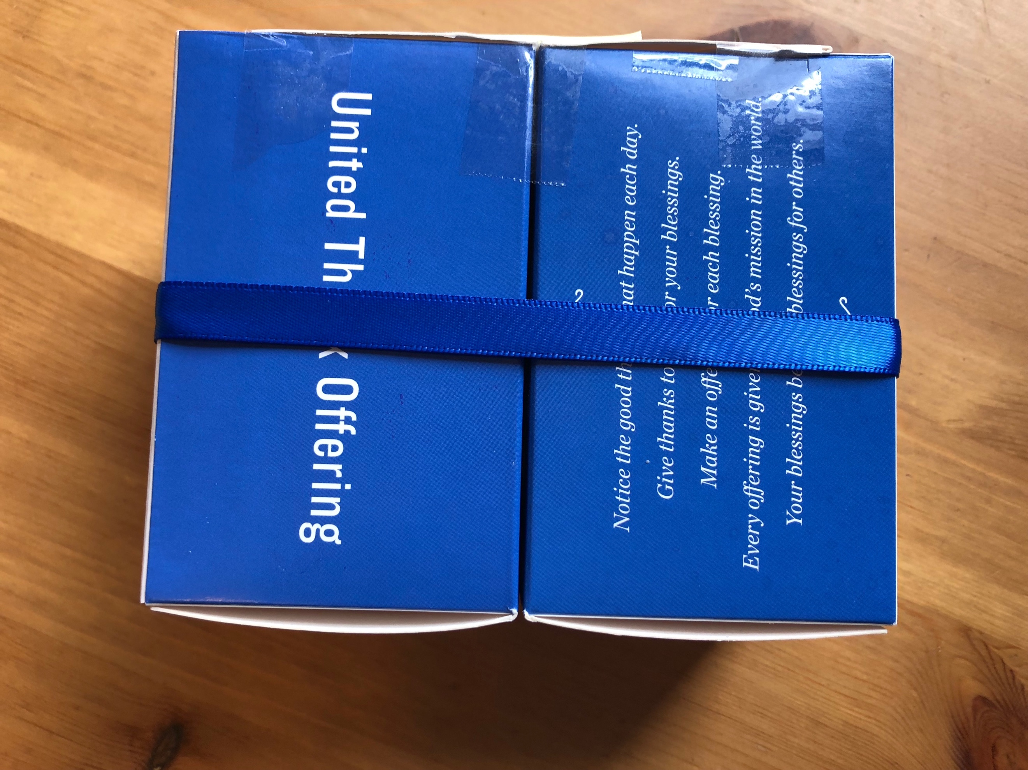
To learn more about UTO or ways to develop your gratitude practices, please visit: www.unitedthankoffering.org

